Desktop Company Files

# Overview

IntuneApp: Desktop Company Files

Puts a Company Files folder on company computers.

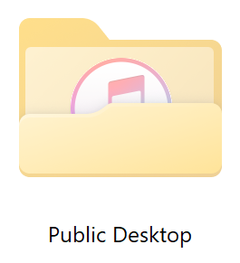

This package will create puts a Company Files folder on company computers.

The folder will be placed in the read-only Public Desktop folder (C:\Users\Public\Desktop).

This is a machine-based folder that all users of the computer will see mixed in with their own desktop.

How to

Drop your company files into the Public Desktop folder within the app

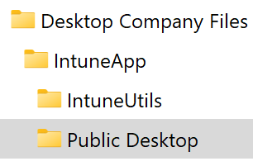

If you have previously deployed a file (or folder) that you want removed, add it to FilesToRemove.csv.

